***White Box Testing:***

* + ***Control Flow Graph (CFG)***
  + ***Cyclomatic Complexity***
  + ***Path testing***

***Control Flow Graph (CFG):*** *A Control Flow Graph (CFG) visually illustrates the organization and execution of a program's statements or instructions. It represents the program's control flow using nodes and directed edges.*

*Each node in the CFG corresponds to either a statement or a basic block—a sequence of statements with a singular entry and exit point.*

*The directed edges between nodes denote the potential flow of control from one statement to another.*

***Cyclomatic Complexity:*** *Cyclomatic complexity is a software metric utilized to gauge the complexity of a program based on its control flow. It offers a quantitative assessment of the number of independent paths within a program's source code.*

*The higher the cyclomatic complexity, the greater the program's complexity, potentially necessitating increased testing and maintenance efforts.*

*The cyclomatic complexity of a program can be calculated using the following formula, known as McCabe's Cyclomatic Complexity (M):*

*M = E - N + 2P*

*Where:*

*E is the number of edges in the control flow graph.*

*N is the number of nodes in the control flow graph.*

*P is the number of connected components (exit points) in the graph.*

***Guidelines:***

*The cyclomatic complexity of 1 indicates a simple, linear program without any branching or decision points.*

*A cyclomatic complexity between 2 and 10 is considered reasonable and manageable.*

*A cyclomatic complexity above 10 suggests a higher level of complexity, indicating that the program may be harder to understand, test, and maintain.*

***Path Testing:***

*Path testing is a software testing method that methodically examines various paths or sequences of statements within a program. Its objective is to guarantee that all conceivable execution paths through the program's source code are scrutinized. This approach aims to enhance test coverage and uncover potential defects or errors.*

*In a Control Flow Graph (CFG), the number of paths corresponds to the cyclomatic complexity.*

***Class EcomSystem:***

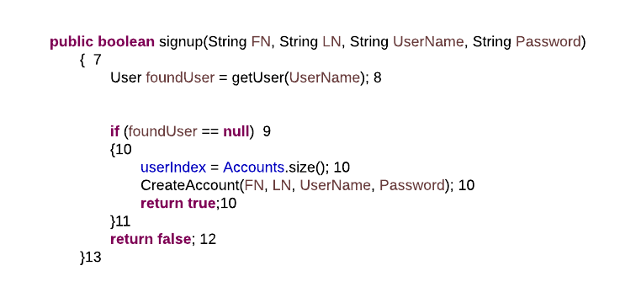

* + ***Cyclomatic Complexity = 24-22+2*3=8***
  + ***Path 1 =1,2,4,6***
  + ***Path 2 =1,2,3,5,6***
  + ***Path 3 =7,8,9,10,11,13***
  + ***Path 4 =7,8,9,12,13***
  + ***Path 5 = 15,16,17,23***
  + ***Path 6 =15,16,18,19,21,22,23***
  + ***Path 7 = 15,16,18,19,20,23***
  + ***Path 8 =15,16,18,19,21,20,23***

***User class***

* + ***Cyclomatic Complexity = 16-14+2*2=6***
  + ***Path 1 =1,2,3,4,7***
  + ***Path 2 =1,2,3,5,2,6,7***
  + ***Path 3 =1,2,6,7***
  + ***Path 4 =8,9,10,11,14***
  + ***Path 5 = 8,9,13,14***
  + ***Path 6 =8,9,10,12,9,13,14***

***Order Class***

* + ***Cyclomatic Complexity = 33-31+2*4=10***
  + ***Path 1 =1,2,3,4,11***
  + ***Path 2 =1,2,3,5,6,11***
  + ***Path 3 =1,2,3,5,7,8,11***
  + ***Path 4 =1,2,3,5,7,9,10,11***
  + ***Path 5 = 12,13,14,15,18,19***
  + ***Path 6 =12,13,14,16,17,18,19***
  + ***Path 7 = 20,21,22,23,21,24***
  + ***Path 8 = 20,21,24***
  + ***Path 9 = 26,27,28,29,30,31***
  + ***Path 10 = 26,27,28,29,30,28,31***

***Cart Class***

* + ***Cyclomatic Complexity = 21-21+2*3=6***
  + ***Path 1 =1,2,3,4,3,5,6***
  + ***Path 2 =1,2,3,5,6***
  + ***Path 3 =7,8,9,11,12,13***
  + ***Path 4 =7,8,9,10,13***
  + ***Path 5 = 14,15,16,17,20,21***
  + ***Path 6 =14,15,16,18,19,20,21***

***Visa Class***

* + ***Cyclomatic Complexity = 14-13+2*2=5***
  + ***Path 1 =1,2,3,4,8***
  + ***Path 2 =1,2,3,5,7,8***
  + ***Path 3 =1,2,3,5,6,8***
  + ***Path 4 =9,10,11,13***
  + ***Path 5 = 9,10,12,13***